



adges UI components library

**Component ID #1 – ex-sxa-event-details - v1.0.0**

## Document Control

## Version History

|  |  |  |  |
| --- | --- | --- | --- |
| Version | Date | Author | Reason for Change |
| 1.0.0 | 11/24/2019 | Tawfik |  |
|  |  |  |  |
|  |  |  |  |
|  |  |  |  |
|  |  |  |  |
|  |  |  |  |
|  |  |  |  |
|  |  |  |  |

## Review History

|  |  |  |
| --- | --- | --- |
| Version | Reviewer | Date |
|  |  |  |
|  |  |  |
|  |  |  |
|  |  |  |
|  |  |  |
|  |  |  |
|  |  |  |

Table of Contents

Document Control 1

Version History 1

Review History 1

1. Document and components Purpose. 3

2. General Information. 3

3. How to use. 3

4. Component features and configure. 4

5. How to configure component. 4

6. Examples 4

# 

# Document and components Purpose.

The purpose of the document is to guide how use and configure [Dynamic Highlight] component.

The purpose of the dynamic highlight you can add any features or latest item on your site with image background or video and you can configure the component based on your branding guideline.

# General Information.

Component Name: Sxa-event-details.

Extension Theme: ex-sxa-event-details.

Owner: Tawfik.

Version no: v1.0.0

Design

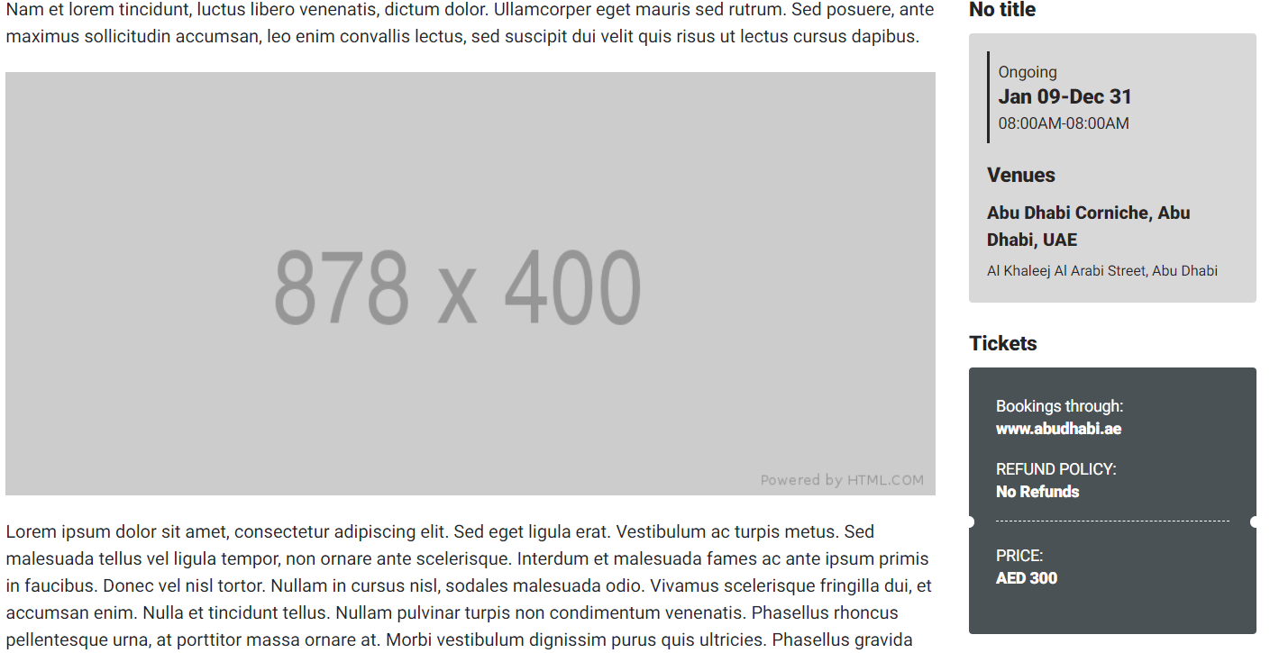

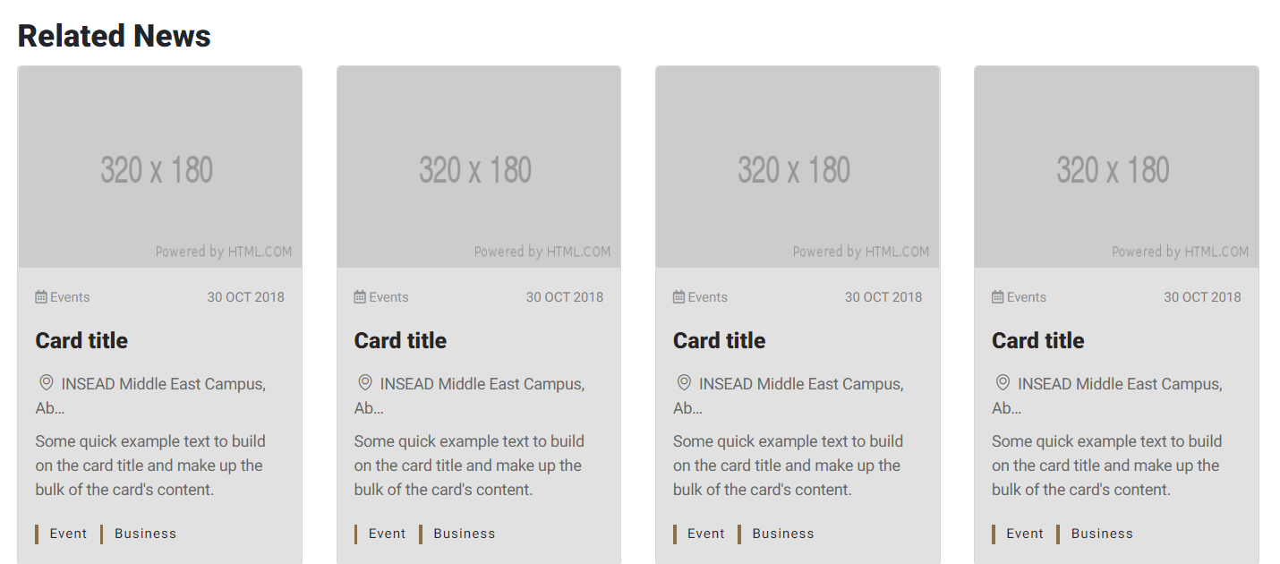

# How to use.

1. The available commands for this project .
   1. Compile : npm run gulp compile -- –path ex-sxa-event-details –extension
   2. Compile & include under ADGE tenant : npm run gulp compile -- –path ex-sxa-event-details –extension –full –dest [ADGEFolder]
   3. Deploy : npm run gulp deploy -- –path ex-sxa-event-details –extension
2. *Now project have full copy from this extension theme under the project theme and you can apply the project brand guideline and configure component based on project needs.*

# Component features and configure.

You have access now to configure component with the below item.

|  |  |  |
| --- | --- | --- |
| Feature | Variable | Default value |
|  |  |  |
|  |  |  |

# How to configure component.

You need to copy all variable that’s you need to change from file _variables.scss under vars folder under the extension theme component, then past the copy variables in file _custom.scss under vars folder under the project theme folder.

# Dependencies

components-sxa-event-details.cs

# Examples

Examples1:

I need to change text color.

I’ll copy the below variables from extension theme.

$highlight-main-tittle-color: $primary-color;

Then will paste the above variable in project folder theme in file _custom.scss and change with any variable based on site needs.

$highlight-main-tittle-color: $secondary-color;

Examples2:

I need to the button shape from square to had a rounded corner.  
I’ll copy the below variables from extension theme.

$button-shape-square: $border-radius-value;

$border-radius-value: 0px;

Then will paste the a above variable in project folder theme in file _custom.scss and change with any variable based on site needs.

$button-shape-square: $border-radius-value;

$border-radius-value: 20px;